Welcome!
Date
Name
Spouse
Address
City
State Zip _________
Email

Please Contact By
❑ Card  Phone  Visit

Telephone Best Time to Call
Home ______________
Work ______________

Guest: First Time Second Time
Are you a church member: yes no
Church
City, State

Circle Appropriate Age/Grade Group(s)
Preschool: Ages: B-1 2-3 4-5
Children: Grades: K 1 2 3 4 5 6
Youth: Grades: 7 8 9 10 11 12
Adults: Ages:18-29 30s 40s 50s 60s+

How did you learn about our church?
Newspaper Friend Yellow Pages Mail
Other

I am a guest of:

New in the Community? Yes No

Thanksgiving Meals Baskets

Every year we reach out to families that are in need. If you would like to help in this ministry, the next few weeks we’ll be collecting items. There is a sign-up sheet at the church. Together we all can spread our love and supply these families with a Thanksgiving meal. Please contact Evelyn Robinson to help!!
Names & ages of children at home

Weekly Service & Activity Schedule
November 24, 2013
9:45 a.m. Sunday School
11:00 a.m. Morning Worship

6:00 p.m. Evening Service

Week of November 25 – 30

Wednesday, 6:30 p.m. Youth Activities
Wednesday, 6:45 p.m. Adult Prayer & Bible Study
Wednesday, 7:30 p.m. Praise Team Rehearsal
Thursday Thanksgiving

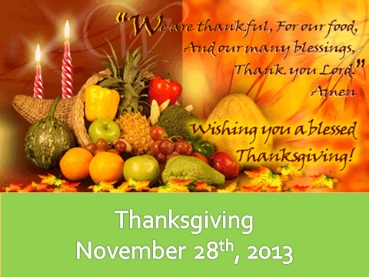
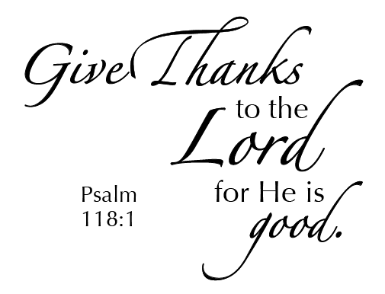

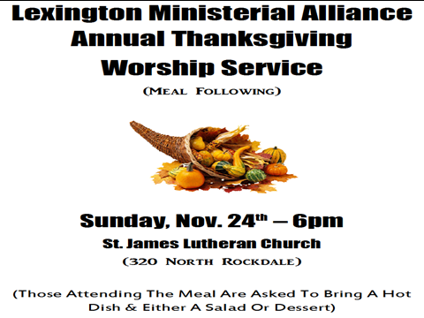
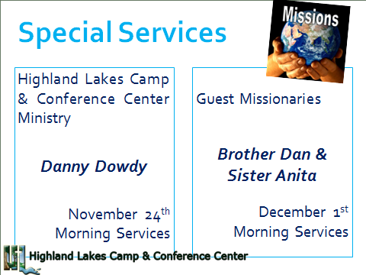

Knobbs Springs Baptist Church

“Be careful not to practice your righteousness in front
of others to be seen by them. If you do,
you will have no reward from your Father in heaven.
“So when you give to the needy, do not announce
it with trumpets, as the hypocrites do in the
synagogues and on the streets, to be honored by
others. Truly I tell you, they have received
their reward in full. But when you give to the needy,
do not let your left hand know what your right
hand is doing, so that your giving may be in secret.
Then your Father, who sees what is done in secret,
will reward you. “And when you pray,
do not be like the hypocrites, for they love to pray
standing in the synagogues and on the street corners
to be seen by others. Truly I tell you, they have
received their reward in full. But when you pray,
go into your room, close the door and pray
to your Father, who is unseen. Then your Father,
who sees what is done in secret, will reward you.
And when you pray, do not keep on babbling like
pagans, for they think they will be heard because of
their many words. Do not be like them, for your
Father knows what you need before you ask him.
Matthew 6:1-8

November 24, 2013

Church Information:
KnobbsSpringsBC.com KnobbsSpringsBaptist@gmail.com
1662 CR 305, McDade, Texas 78650 512-273-2743
Brother Dwight Reagan 512-247-6448
Kimberly Tabor, Office Manager 512-698-2804

